**ER DIAGRAM OF LIBRARY MANAGEMENT SYSTEM**

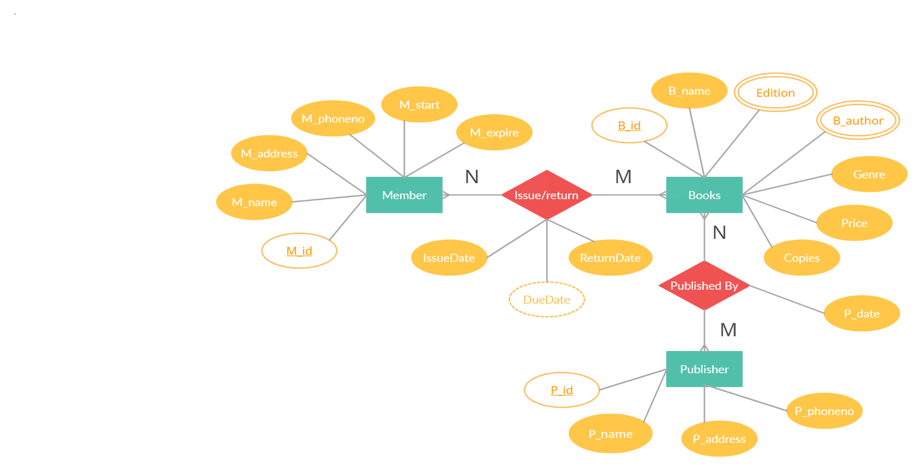

Made using: - <https://creately.com/>

**Entities: -**

1. Member – ( M_id, M_name, M_address, M_phoneno, M_start, M_expire)
2. Books – ( B_id, B_name, B_author, Edition, Genre, Price, Copies)
3. Publisher – ( P_id, P_name, P_address, P_phoneno)

**Relationship: -**

1. Member **Issue/Return** Books

Issue_Return – ( M_id, B_id, IssueDate, DueDate, ReturnDate)

1. Books **Published By** Publisher

Published – ( B_id, P_id, P_date)

**ER DIAGRAM TO RELATIONAL MODEL**

CREATE TABLE Member(

M_id varchar(8) primary key,

M_name varchar(20) not null,

M_address varchar(30) not null,

M_phoneno int8 not null unique,

M_start date not null,

M_expire date not null,

constraint ck_no check (M_phoneno>0 and length(M_phoneno) =10),

constraint ck_mship check(M_start<M_expire));

CREATE TABLE Books(

B_id varchar(8) primary key,

B_name varchar(20) not null,

Genre varchar(20)not null,

Price numeric(10,2) not null,

Copies int default 0,

constraint ck_cp check(Copies>=0),

constraint ck_price check(Price>0));

**For Multivalued Attributes Edition and B_author , created two different relation having B_id as primary key : -**

CREATE TABLE Book_edition(

B_id varchar(8),

Edition int,

Primary key( B_id, Edition ),

constraint ck_ed check( Edition>0 ),

foreign key( B_id ) references Books( B_id )

on delete cascade);

CREATE TABLE Book_author(

B_id varchar(8),

B_author varchar(20),

Primary key( B_id, B_author ),

foreign key(B_id) references Books( B_id )

on delete cascade);

CREATE TABLE Publisher(

P_id varchar(8) primary key,

P_name varchar(20) not null,

P_address varchar(30) not null,

P_phoneno int8 not null,

constraint ck_no check(P_phoneno>0 and length(P_phoneno)=10));

CREATE TABLE Published(

B_id varchar(8),

P_id varchar(8),

P_date date not null,

Primary key( B_id, P_id ),

foreign key( B_id ) references Books( B_id )

on delete cascade,

foreign key( P_id ) references Publisher( P_id )

on delete cascade);

CREATE TABLE Issue_Return(

M_id varchar(8),

B_id varchar(8),

IssueDate date not null,

DueDate date not null,

ReturnDate date,

Primary key(M_id,B_id),

constraint ch_date check(IssueDate<DueDate),

foreign key(M_id) references Member(M_id)

on delete cascade,

foreign key(B_id) references Books(B_id)

on delete cascade);